DECEPTION-AS-A-SERVICE: AN ADAPTIVE AI-POWERED HONEYPOT NETWORK FOR PROACTIVE CYBER DEFENCE

A PROJECT REPORT
Submitted by

SANTHOSH S | (312822205041)
TAMIZHARASU M | (312822205052)

in partial fulfillment for the award of the degree
of
BACHELOR OF TECHNOLOGY
in
INFORMATION TECHNOLOGY



AGNI COLLEGE OF TECHNOLOGY

(An Autonomous Institution)
(Affiliated to Anna University, Chennai)
APRIL 2026

AGNI COLLEGE OF TECHNOLOGY
(An Autonomous Institution, Affiliated to Anna University, Chennai)

BONAFIDE CERTIFICATE

Certified that this project report “DECEPTION-AS-A-SERVICE: AN ADAPTIVE AI-POWERED HONEYPOT NETWORK FOR PROACTIVE CYBER DEFENCE” is the Bonafide work of “SANTHOSH S (312822205041), TAMIZHARASU M (312822205052)” who carried out the project work under my supervision.

SIGNATURE | SIGNATURE
Dr.G. SIMI MARGARAT, M.Tech, Ph.D | M. Kamatchisaranya, M.E
HEAD OF THE DEPARTMENT | SUPERVISOR
Department of Information  Technology | Department of Information  Technology
Agni College of Technology,  Thalambur, Chennai –600130 | Agni College of Technology,  Thalambur, Chennai - 600130

Submitted for the project viva held on …………………………

SIGNATURE OF INTERNAL EXAMINER | SIGNATURE OF EXTERNAL EXAMINER

ACKNOWLEDGEMENT

We would like to express our deepest gratitude to the management of
AGNI COLLEGE OF TECHNOLOGY and would like to thank our respected Principal Dr. SRINIVASAN ALAVANDAR., for his words of inspiration and for providing the necessary facilities to carry out our project work successfully.

We are immensely thankful to Dr.G. SIMI MARGARAT, M.Tech, Ph.D., professor, Head of the Department, Information Technology for her words of wisdom and her constant source of inspiration.

I would like to offer our heartfelt thanks to our guide to
Mrs. M. KAMATCHISARANYA, M.E., Assistant professor of Information Technology who molded us accordingly and gave valuable suggestion for completing our project work successfully.

We extended our warmest thanks to all the faculty members of our department for their assistance and we also thank all our friends who helped us in bringing out our project in good shape and form.

Finally, we express our sincere benevolence to our beloved parents for their perpetual encouragement and support in all endeavors.

ABSTRACT

Cybersecurity has become a critical concern in the modern digital era due to the rapid increase in sophisticated cyberattacks. Traditional security mechanisms such as firewalls, intrusion detection systems (IDS), and antivirus software are primarily reactive in nature and often fail to detect unknown or zero-day attacks. Honeypots, which act as decoy systems to attract attackers, provide an effective way to study attacker behavior and gather threat intelligence. However, conventional honeypots are static and can be easily identified by attackers, limiting their effectiveness. This project introduces Deception-as-a-Service (DaaS), an adaptive AI-powered honeypot framework designed to enhance cybersecurity through dynamic deception techniques. The proposed system integrates lightweight honeypots such as Cowrie (SSH/Telnet) and Dionaea (malware capture), combined with the ELK stack (Elasticsearch, Logstash, Kibana) for centralized log collection, processing, and visualization. Machine learning techniques, including Isolation Forest for anomaly detection and Random Forest for attack classification, are employed to analyze attacker behavior in real time. The system dynamically adapts its behavior using a Flask-based orchestration layer, which modifies honeypot configurations such as SSH banners, fake credentials, and file systems based on detected attack patterns. Experimental results demonstrate that the adaptive honeypot significantly outperforms static systems, achieving a detection accuracy of 97.8%, improving session duration by 182%, and increasing commands per session by 175%. The findings highlight the effectiveness of integrating machine learning with adaptive deception techniques to create a proactive cybersecurity defense system.

 | TABLE OF CONTENTS
CHAPTER NO. | TITLE | PAGE NO
 | ABSTRACT | I
 | LIST OF TABLES | IV
 | LIST OF FIGURES | V
 | LIST OF ABBREVIATIONS | VI
1. | INTRODUCTION | 1
 | 1.1 INTRODUCTION | 1
 | 1.2 OBJECTIVE | 2
2. | LITERATURE SURVEY | 3
3. | SYSTEM ANALYSIS | 8
 | 3.1 EXISTING SYSTEM | 8
 | 3.2 DISADVANTAGE | 9
 | 3.3 PROPOSED SYSTEM | 9
 | 3.4 ADVANTAGE | 10
4. | SYSTEM REQUIREMENTS | 11
 | 4.1 FUNCTIONAL REQUIREMENTS | 11
 | 4.2 NON-FUNCTIONAL REQUIREMENTS | 12
 | 4.3 ENVIRONMENT REQUIREMENTS | 12
5. | SYSTEM DESIGN | 15
 | 5.1 SYSTEM ARCHITECTURE | 15
 | 5.2 WORK FLOW DIAGRAM | 17
 | 5.3 USE CASE DIAGRAM | 18
 | 5.4 CLASS DIAGRAM | 19
 | 5.5ACTIVITY DIAGRAM | 20
 | 5.6 SEQUENCE DIAGRAM | 21
 | 5.7 ER DIAGRAM | 22
6. | SYSTEM IMPLEMENTATION | 23
 | 6.1 LIST OF MODULES | 23
 | 6.2 MODULE DESCRIPTION | 23
 | 6.2.1 DATA COLLECTION LAYER | 23
 | 6.2.2 INTELLIGENCE PROCESSING LAYER | 23
 | 6.2.3 ISOLATION FOREST | 25
 | 6.2.4 RANDOM FOREST CLASSIFIER | 26
 | 6.2.5 ADAPTATION AND RESPONSE LAYER | 27
 | 6.3 PROPOSED METHODOLOGY | 27
 | 6.3.1 FEATURE ENGINEERING | 28
 | 6.3.2 MACHINE LEARNING PIPELINE | 28
 | 6.3.3 TRAINING PROCESS | 28
 | 6.3.4 VALIDATION PROCESS | 28
 | 6.4 DEPLOY | 29
7. | CODING AND TESTING | 30
 | 7.1 VALUE CONVENTIONS | 30
 | 7.2 SCRIPT WRITING & COMMENTING STANDARD | 30
 | 7.3 MESSAGE BOX FORMAT | 31
8. | SYSTEM DESCRIPTION | 32
 | 8.1 DOCKER CONTAINERIZATION | 32
 | 8.2 ELASTICSEARCH | 32
 | 8.3 PYTHON AND FLASK | 32
9. | CODING | 33
 | 9.1 CODING | 33
 | 9.2 SCREENSHOTS | 40
 | 9.2.1 API HEALTH CHECK | 40
 | 9.2.2 KIBANA DASKBOARD | 41
 | 9.2.3 ADAPTIVE RESPONSE API OUTPUT | 41
 | 9.2.4 ATTACKER SESSION INSIDE HONEYPOT | 42
10. | RESULT AND DISCUSSION | 43
 | 10.1 RESULT | 43
 | 10.2 CONCLUSION | 45
 | 10.3 FUTURE WORK | 45
11. | REFERENCE | 46
12. | IEEE PAPER | 50

LIST OF TABLES

TABLE NO | TITLE | PAGE
4.3.1 | Software Requirements | 12
4.3.2 | Hardware requirements | 13
4.3.3 | ELK Stack Infrastructure | 13
4.3.4 | Orchestration Service | 14

LIST OF FIGURES

FIGURE NO | TITLE | PAGE
5.1 | System Architecture Diagram | 15
5.2 | Work flow Diagram | 17
5.3 | Use Case Diagram | 18
5.4 | Class Diagram | 19
5.5 | Activity Diagram | 20
5.6 | Sequence Diagram | 21
5.7 | ER Diagram | 22
6.2.2 | Intelligence Processing Diagram | 24
6.2.3 | Isolation Forest Diagram | 26
6.2.4 | Random Forest Diagram | 26
9.2.1 | Api Health Check | 40
9.2.2 | Kibana Dashboard | 41
9.2.3 | Adaptive Response Api Output | 41
9.2.4 | Attacker Session Inside Honeypot | 42
10.1 | Isolation Forest Graph | 44
10.2 | Random Forest Graph | 44

LIST OF ABBREVIATION

ML | Machine Learning
AI | Artificial Intelligence
IDS | Intrusion Detection System
IPS | Intrusion Prevention System
ELK | Elasticsearch, Logstash, Kibana
API | Application Programming Interface
RF | Random Forest
IF | Isolation Forest
DaaS | Deception-as-a-Service
JSON | JavaScript Object Notation
SQL | Structured Query Language
GUI | Graphical User Interface

CHAPTER 1

  - INTRODUCTION

Cyberattacks have become increasingly complex and frequent, posing significant risks to organizations, governments, and individuals. Attackers use automated tools, botnets, and advanced techniques such as polymorphic malware and zero-day exploits to bypass traditional security systems. Conventional defenses like firewalls and intrusion detection systems are often reactive, meaning they respond only after an attack has occurred. Honeypots provide an alternative approach by acting as decoy systems that lure attackers into interacting with them. These systems are designed to appear as legitimate targets while capturing valuable information about attacker behavior. However, traditional honeypots are static in nature and lack adaptability. Once attackers identify them as decoys, they abandon the interaction, resulting in limited intelligence collection. To overcome these limitations, this project proposes an adaptive honeypot system that dynamically responds to attacker behavior. By integrating machine learning techniques, the system can detect anomalies, classify attack types, and adjust its behavior in real time. This results in prolonged attacker engagement and improved threat intelligence. The proposed system follows a layered architecture consisting of data collection, intelligence processing, and adaptation layers. Honeypots collect attack data, which is processed using the ELK stack and analyzed using machine learning models. Based on the analysis, adaptive responses are triggered to modify the honeypot environment. This approach transforms honeypots from passive monitoring tools into active defense mechanisms, enabling proactive cybersecurity.

  - OBJECTIVE

The main objectives of this project are to design and implement an adaptive honeypot system capable of dynamically responding to cyberattacks, integrate machine learning models for real-time anomaly detection and attack classification, improve attacker engagement time and increase interaction depth, compare the performance of static and adaptive honeypots, develop a centralized monitoring system using the ELK stack, and create a scalable and cost-effective cybersecurity solution.
CHAPTER 2

LITERATURE SURVEY

[1] Project Title : A Survey of Contemporary Open-Source Honeypots, Frameworks and Tools
Author: N. Ilg, P. Duplys, D. Sisejkovic, M. Menth
Year: 2023
This study focuses on a systematic survey of open-source honeypot software including Cowrie, Dionaea and MHN, evaluating logging capabilities, deployment mechanisms, and evasion resistance. The authors proposed an evaluation framework that analyzes various honeypot tools to identify their strengths and limitations in real-world deployment scenarios. In order to enhance the quality of honeypot selection, several criteria were applied including JSON logging support, containerization compatibility, and fingerprint resistance before performing the comparative analysis. These evaluation steps help improve the effectiveness of honeypot deployment and ensure better threat intelligence collection from attacker interactions. The study identified Cowrie as the leading SSH honeypot with comprehensive JSON logging capabilities, while Dionaea emerged as the standard solution for malware capture. However, the research revealed that static honeypots can be fingerprinted within minutes by sophisticated attackers. The experimental results indicated that open-source honeypots lack adaptive capabilities and do not integrate machine learning-based detection or response pipelines. The study highlights the need for integrated adaptive layers combining open-source honeypots with real-time ML reconfiguration in cybersecurity defense systems.

[2] Project Title : Using Reinforcement Learning to Conceal Honeypot Functionality
Author: S. Dowling, M. Schukat, E. Barrett
Year: 2019
This study focuses on enhancing honeypot engagement using reinforcement learning techniques applied to SSH honeypot systems. The authors proposed a SARSA-based reinforcement learning agent implemented on a modified Cowrie SSH honeypot, where the HARM (Honeypot Adaptive Response Module) learns optimal command responses that maximize attacker engagement across scripted attack episodes. In order to enhance the quality of attacker interaction, several adaptive response strategies were applied to dynamically adjust honeypot behavior based on observed attack patterns before performing the classification process. These adaptive response steps help improve the effectiveness of the honeypot system and ensure better intelligence collection from prolonged attacker sessions. The study implemented reinforcement learning algorithms to optimize honeypot responses in real-time scenarios. The RL-based adaptive responses demonstrated significant increases in attacker engagement time compared to static honeypot configurations, confirming that Cowrie serves as a viable platform for response adaptation. The performance of the RL-enhanced honeypot was evaluated and compared based on engagement duration metrics. The experimental results indicated that reinforcement learning models achieved better performance and higher engagement rates compared to traditional static honeypot approaches. However, the study was tested only on automated malware scenarios, and the full RL pipeline proved complex for small laboratory deployments.

[3] Project Title : Adaptive Honeypot Engagement through Reinforcement Learning of Semi-Markov Decision Processes
Author: L. Huang, Q. Zhu
Year: 2019

This study focuses on optimizing honeypot-attacker interactions using advanced decision-theoretic frameworks combined with reinforcement learning techniques. The authors proposed a system that models attacker-honeypot interactions as Semi-Markov Decision Processes (SMDP) to optimize both action selection and response timing in adaptive defense scenarios. In order to enhance the quality of engagement strategies, several temporal analysis techniques were applied to determine optimal response timing and action sequences before performing the defensive adaptation process. These SMDP modeling steps help improve the effectiveness of honeypot engagement and ensure better attacker retention through strategically timed responses. The study implemented both traditional reinforcement learning algorithms and SMDP-based optimization models for honeypot behavior control. The research demonstrated that the timing of adaptive responses is critical to maintaining attacker engagement, with simple actions such as presenting fake credentials and filesystem expansion measurably increasing engagement time and interaction depth. The performance of these models was evaluated based on engagement duration and information gathering metrics. The experimental results indicated that SMDP-based approaches achieved better performance in balancing immediate responses with long-term engagement objectives compared to traditional static or simple reactive honeypot systems.

[4] Project Title : Isolation-Based Anomaly Detection
Author: F. T. Liu, K. M. Ting, Z.-H. Zhou
Year: 2012
This study focuses on unsupervised anomaly detection in high-dimensional datasets using isolation-based machine learning techniques. The authors proposed an algorithm that isolates anomalies through random recursive partitioning, where anomalous data points are separated in fewer steps than normal points without requiring labeled training data. In order to enhance the quality of anomaly identification, several tree-based isolation strategies were applied to efficiently partition the feature space and identify outliers before performing the anomaly scoring process. These isolation steps help improve the effectiveness of anomaly detection models and ensure better scalability on large-scale datasets with minimal computational overhead. The study implemented the Isolation Forest algorithm, which builds an ensemble of random decision trees to isolate data points efficiently. The experimental results demonstrated near-perfect AUC scores on standard anomaly detection benchmarks, with the algorithm scaling linearly with data size and outperforming density-based and distance-based methods on high-dimensional tabular data. The performance of Isolation Forest was evaluated and compared based on detection accuracy, computational efficiency, and scalability metrics. The experimental results indicated that isolation-based models achieved better performance and higher detection rates compared to traditional anomaly detection algorithms in diverse application domains.

[5] Project Title : A Survey on Honeypot Software and Data Analysis
Author: M. Nawrocki, M. Wahlisch, T. C. Schmidt, C. Keil, J. Schonfelder
Year: 2016

This study focuses on comprehensive taxonomic classification of honeypot systems and analysis methodologies for extracting actionable intelligence from honeypot data. The authors proposed a classification framework that categorizes honeypots by interaction level (low, medium, high) and reviews feature engineering and analysis methods applicable to session log data collected from various honeypot deployments. In order to enhance the quality of threat intelligence extraction, several statistical and behavioral feature engineering techniques were applied to honeypot session logs, analyzing metrics such as session duration, command frequency, and file download patterns before performing the threat profiling process. These feature extraction steps help improve the effectiveness of attacker behavior analysis and ensure better threat characterization from collected honeypot data. The study examined both supervised and unsupervised machine learning methods for honeypot data analysis. The research identified that session length, command count, and download attempts serve as the strongest features for attacker profiling, with unsupervised methods being preferred when labeled ground-truth data is unavailable. The study highlights the foundational understanding of honeypot data analysis methodologies while identifying the need for automated feature extraction pipelines that feed directly into real-time honeypot behavior control systems for adaptive defense mechanisms.

CHAPTER 3

SYSTEM ANALYSIS

3.1 EXISTING SYSTEM:

The existing methods for detecting and analyzing cyber attacks primarily rely on traditional network security tools and static honeypot deployments. In most organizations, security is maintained using firewalls, intrusion detection systems (IDS), and intrusion prevention systems (IPS). These systems monitor network traffic, identify suspicious patterns based on predefined rules or signatures, and generate alerts. Security analysts then manually review these alerts to determine whether they represent real threats or false positives. Along with these mechanisms, honeypots are deployed to attract attackers and collect intelligence by simulating vulnerable services such as SSH, web servers, and databases.
Traditional honeypots operate with fixed configurations and predefined response patterns. They log attacker activities such as login attempts, commands executed, and malware downloads, which are later analyzed by security professionals. However, analyzing large volumes of log data manually is time-consuming and resource-intensive. The effectiveness of this process heavily depends on the expertise of security analysts, and delays in analysis may allow attackers to continue their activities undetected. Additionally, some systems use basic machine learning techniques with limited features, which often fail to capture complex attack patterns in modern cyber threats.
A major limitation of existing systems is the static nature of honeypots. Skilled attackers can identify honeypots using fingerprinting techniques by detecting inconsistencies in system behavior.

3.2 DISADVANTAGES:

    - Manual Analysis Requirements: Traditional honeypots require manual log analysis, which is time-consuming and causes delays in detecting and responding to attacks.
    - Static Configuration Vulnerability: Conventional honeypots use fixed configurations, making them easy for attackers to identify and avoid.
    - Limited Pattern Recognition: Basic statistical or simple machine learning methods fail to detect complex and advanced attack patterns.
    - Dependence on Expert Knowledge: Accurate threat detection depends on the experience of security analysts, leading to inconsistencies and possible human errors.
    - Lack of Real-Time Adaptation: Existing systems do not adapt dynamically to changing attack behavior, reducing their effectiveness over time.

3.3 PROPOSED SYSTEM:

The proposed Deception-as-a-Service (DaaS) system overcomes the limitations of static honeypots by introducing an adaptive three-tier architecture that integrates containerized honeypots with machine learning for intelligent threat detection and response. The system is designed to be scalable, cost-effective, and suitable for organizations of all sizes. It follows a structured workflow consisting of data collection, intelligent processing, and adaptive response, implemented using Docker-based microservices for better isolation, portability, and efficiency.
In the data collection layer, lightweight honeypots such as Cowrie and Dionaea are deployed to simulate real-world services and capture attacker activities. These honeypots log interactions including login attempts, commands, and malware downloads. Filebeat agents forward these logs to a centralized system for further analysis. The intelligence processing layer uses the ELK stack, where Logstash processes logs, Elasticsearch stores and indexes data, and Kibana provides visualization dashboards. Feature engineering extracts key attributes such as session duration, command patterns, authentication attempts, and network details, which are used for machine learning analysis.
The system uses a hybrid machine learning approach combining Isolation Forest for anomaly detection and Random Forest for attack classification. Isolation Forest identifies unusual behavior without requiring labeled data, while Random Forest classifies attacks into categories such as brute force, scanning, and malware activity. This combination improves detection accuracy and enables identification of both known and unknown threats.

3.4 ADVANTAGES:

- We build a framework-based adaptive honeypot system for deployment purposes.
- We use machine learning techniques to detect and classify cyber attacks.
- Accuracy and performance level are significantly improved.
- We implement data analysis using dashboards, charts, and visualizations.
- We compare multiple algorithms to achieve better detection accuracy.

CHAPTER 4

SYSTEM REQUIREMENTS

Requirements are the basic constrains that are required to develop a system. Requirements are collected while designing the system. The following are the requirements that are to be discussed.
1. Functional requirements
2. Non-Functional requirements
3. Environment requirements
A. Hardware requirements
B. software requirements

4.1 FUNCTIONAL REQUIREMENTS:
The software requirements specification defines the functional capabilities of the Deception-as-a-Service honeypot system, outlining the features the system must perform. The system must support data collection through containerized honeypots like Cowrie and Dionaea, capturing attacker interactions such as login attempts, commands, and payloads. It must implement a log processing pipeline using Filebeat, Logstash, and Elasticsearch to ensure reliable log transmission and processing. The system should perform real-time feature engineering by extracting relevant attributes from log data for analysis. Machine learning models such as Isolation Forest and Random Forest must be used for anomaly detection and attack classification. Additionally, the system must include an adaptive orchestration layer using Flask to dynamically modify honeypot behavior based on detected threats. It should provide visualization through Kibana dashboards for effective monitoring and generate alerts when suspicious activities are detected to support security operations.
4.2 NON-FUNCTIONAL REQUIREMENTS:
Process of Functional Steps: The system implementation follows a structured methodology:
- Problem definition identifying threat detection and intelligence collection requirements
- Data preparation collecting and organizing honeypot log data
- Feature engineering extracting relevant characteristics from raw logs
- Algorithm implementation training and evaluating machine learning models
- Adaptive system development building orchestration logic for configuration modification
- Validation and testing evaluating system performance and effectiveness
- Deployment and monitoring operating the system in production environments

4.3 ENVIRONMENTAL REQUIREMENTS:
1. Software Requirements:
Table 4.3.1 : Software Requirements
Component | Specification
Operating System | Ubuntu Server 22.04 LTS
Containerization | Docker 24.0 with Docker Compose 2.20
Honeypot Software | Cowrie 2.5, Dionaea 0.11
Log Forwarding | Filebeat 8.9
Search and Analytics | Elasticsearch 8.9
Log Processing | Logstash 8.9
Visualization | Kibana 8.9
Orchestration Framework | Flask 2.3 with Python 3.11
Machine Learning Libraries | scikit-learn 1.3, NumPy 1.25, Pandas 2.0
Virtualization Platform | VMware Workstation Pro 17.0 or VirtualBox 7.0

2. Hardware requirements:
Table 4.3.2 : Hardware requirements
Component | Minimum | Recommended
Processor | 1 CPU core | 2 CPU cores
Memory | 2 GB RAM | 4 GB RAM
Storage | 20 GB | 40 GB
Network | 100 Mbps | 1 Gbps

3. ELK Stack Infrastructure:
Table 4.3.3 : ELK Stack Infrastructure
Component | Minimum | Recommended
Processor | Intel Xeon or equivalent, 4 cores | 8 cores
Memory (Elasticsearch) | 8 GB RAM | 16 GB RAM
Memory (Logstash) | 4 GB RAM | 8 GB RAM
Memory (Kibana) | 2 GB RAM | 4 GB RAM
Storage | 100 GB SSD | 500 GB SSD with RAID
Network | 1 Gbps | 10 Gbps

4. Orchestration Service:
Table 4.3.4 : Orchestration Service
Component | Minimum | Recommended
Processor | 2 CPU cores | 4 CPU cores
Memory | 4 GB RAM | 8 GB RAM
Storage | 20 GB | 50 GB

CHAPTER 5
SYSTEM DESIGN

System design is the process of defining the architecture, components, modules, interfaces, and data flow for a system to satisfy specified requirements. The design phase translates functional and non functional requirements into a technical blueprint that guides implementation. Effective system design ensures that the resulting implementation will meet stakeholder needs while maintaining quality attributes such as performance, scalability, security, and maintainability.

SYSTEM ARCHITECTURE:

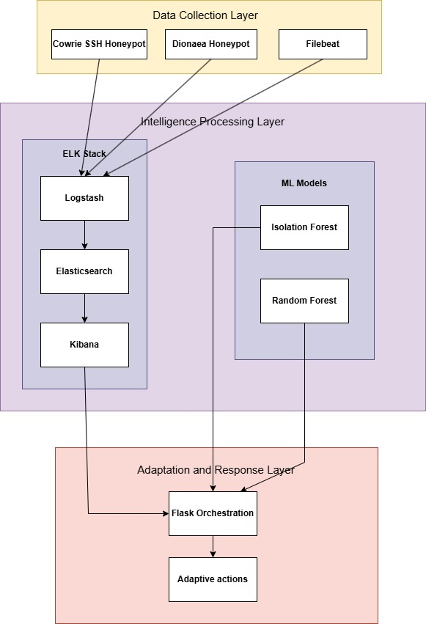
Fig 5.1 : System Architecture Diagram
The Deception-as-a-Service system follows a three-tier architecture consisting of the Data Collection Layer, Intelligence Processing Layer, and Adaptation & Response Layer, ensuring modular design and easy scalability. The Data Collection Layer uses containerized honeypots like Cowrie and Dionaea to capture attacker interactions such as login attempts, commands, and malware activity, with logs forwarded using Filebeat. The Intelligence Processing Layer utilizes the ELK stack, where Logstash processes logs, Elasticsearch stores and indexes data, and Kibana provides visualization. Machine learning models like Isolation Forest and Random Forest analyze extracted features to detect anomalies and classify attacks.
The Adaptation & Response Layer uses a Flask-based orchestrator to dynamically modify honeypot configurations based on detected threats. It performs actions such as credential generation, banner modification, and system behavior adjustments to increase attacker engagement. The system continuously monitors performance and improves its responses over time, making it more effective in collecting threat intelligence.
Figure 5.1 represents the system architecture showing data flow from honeypots to the ELK stack, machine learning analysis, and adaptive response back to the honeypots.

5.2 WORK FLOW DIAGRAM:

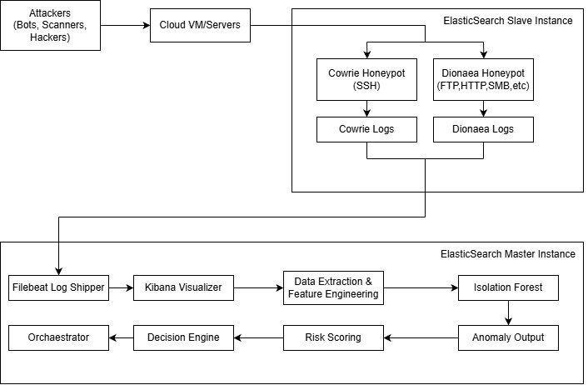
Fig 5.2 : Workflow Diagram

The workflow diagram shows the complete operation of the Deception-as-a-Service system from attack detection to response. Attackers initiate connections to honeypots like Cowrie and Dionaea, where all activities such as login attempts and commands are logged. These logs are processed using Filebeat, Logstash, and Elasticsearch, and relevant features are extracted for analysis. Machine learning models such as Isolation Forest and Random Forest detect anomalies and classify attack types. Based on the results, the system adapts honeypot behavior using an orchestration layer, while Kibana dashboards provide visualization and alerts for monitoring.

5.3 USECASE DIAGRAM:

Use case diagrams are considered for high level requirement analysis of a system. So when the requirements of a system are analyzed the functionalities are captured in use cases. So, it can say that uses cases are nothing but the system functionalities written in an organized manner.

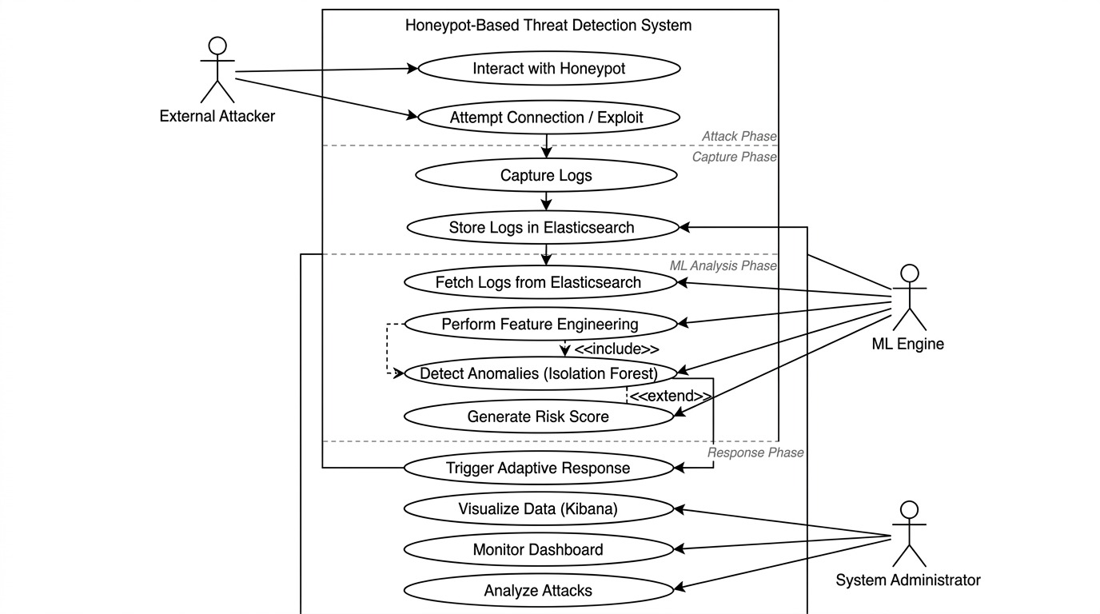

Fig 5.3 : Use case diagram

5.4 CLASS DIAGRAM:

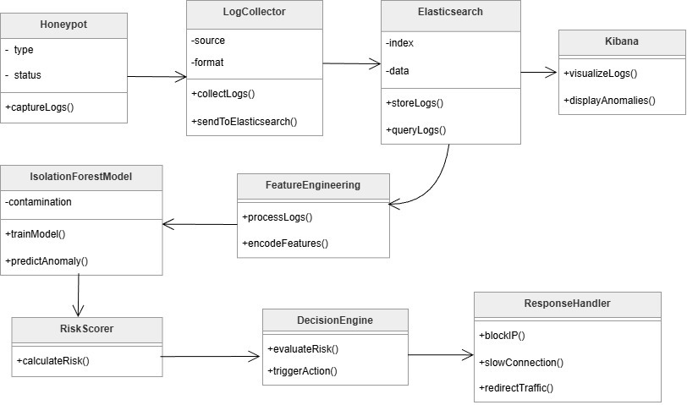

Fig 5.4 : Class diagram

Class diagram is basically a graphical representation of the static view of the system and represents different aspects of the application. So a collection of class diagrams represent the whole system. The name of the class diagram should be meaningful to describe the aspect of the system. Each element and their relationships should be identified in advance Responsibility (attributes and methods) of each class should be clearly identified for each class minimum number of properties should be specified and because, unnecessary properties will make the diagram complicated. Use notes whenever required to describe some aspect of the diagram and at the end of the drawing it should be understandable to the developer/coder. Finally, before making the final version, the diagram drawn on plain paper and rework as many times as possible to make it correct

5.5 ACTIVITY DIAGRAM:

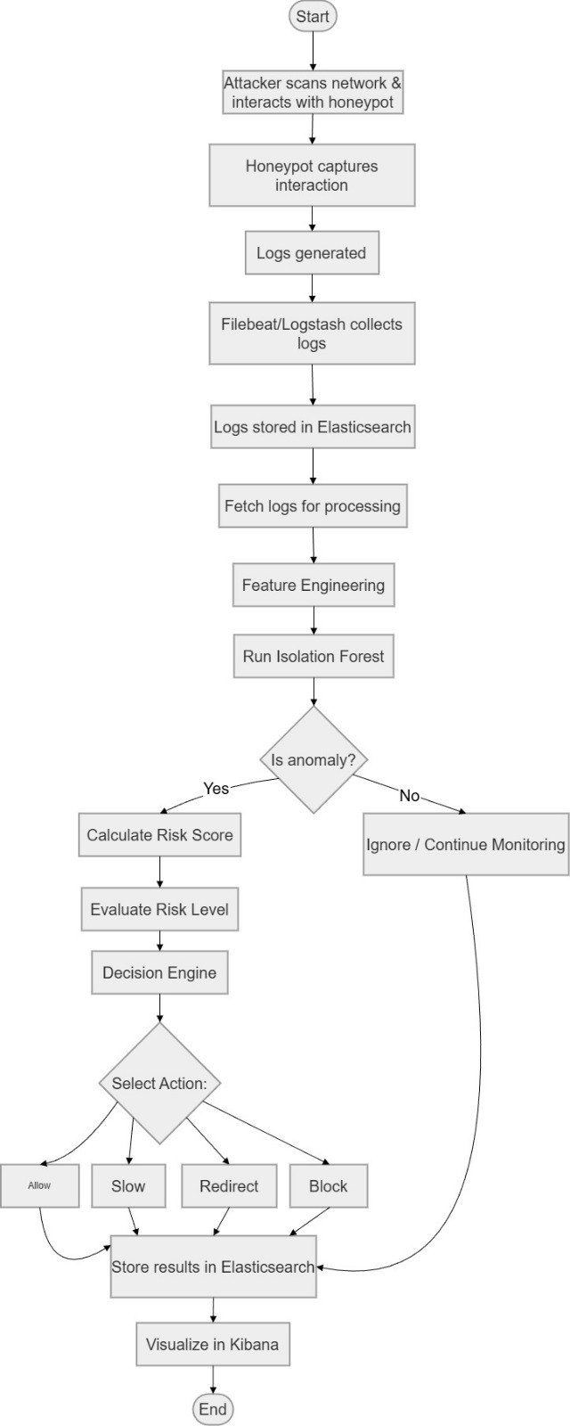

Fig 5.5 : Activity diagram

Activity is a particular operation of the system. Activity diagrams are not only used for visualizing dynamic nature of a system but they are also used to construct the executable system by using forward and reverse engineering techniques. The only missing thing in activity diagram is the message part. It does not show any message flow from one activity to another. Activity diagram is some time considered as the flow chart. Although the diagrams looks like a flow chart but it is not. It shows different flow like parallel, branched, concurrent and single.
5.6 SEQUENCE DIAGRAM:

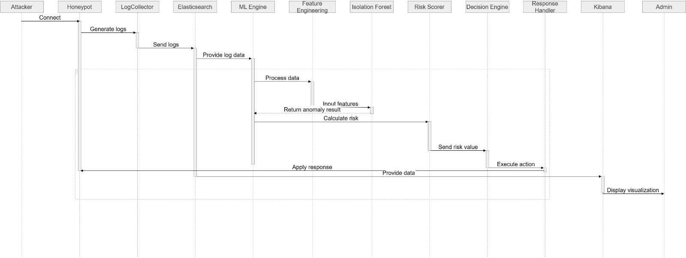

Fig 5.6 : Sequence diagram

Sequence diagrams model the flow of logic within your system in a visual manner, enabling you both to document and validate your logic, and are commonly used for both analysis and design purposes. Sequence diagrams are the most popular UML artifact for dynamic modeling, which focuses on identifying the behavior within your system. Other dynamic modeling techniques include activity, diagramming, communication diagramming, timing diagramming, and interaction overview diagramming. Sequence diagrams, along with class diagrams and physical data models are in my opinion the most important design-level models for modern business application development.

5.7 ER DIAGRAM:

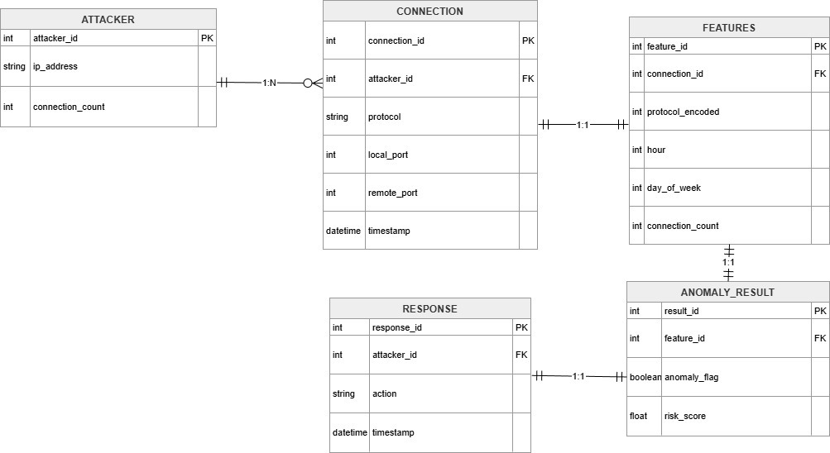

Fig 5.7 : ER diagram

An entity relationship diagram (ERD), also known as an entity relationship model, is a graphical representation of an information system that depicts the relationships among people, objects, places, concepts or events within that system. An ERD is a data modeling technique that can help define business processes and be used as the foundation for a relational database. Entity relationship diagrams provide a visual starting point for database design that can also be used to help determine information system requirements throughout an organization. After a relational database is rolled out, an ERD can still serve as a referral point, should any debugging or business process re-engineering be needed later.
CHAPTER 6

SYSTEM IMPLEMENTATION

  - LIST OF MODULES

- Data Collection Layer including Cowrie and Dionaea honeypot deployment
- Intelligence Processing Layer including ELK stack and feature engineering
- Isolation Forest unsupervised anomaly detection
- Random Forest Classifier supervised attack categorization
- Adaptation and Response Layer including orchestration service

6.2 MODULE DESCRIPTION

6.2.1 Data Collection Layer
The Data Collection Layer is responsible for capturing attacker activities using honeypots. It deploys Cowrie for SSH/Telnet interactions and Dionaea for multi-protocol attacks such as SMB, HTTP, and FTP. These honeypots simulate real systems and record details like login attempts, commands, and malware activity. The logs are continuously monitored and forwarded using Filebeat. Containerization ensures isolation, scalability, and efficient deployment of honeypots.

6.2.2 Intelligence Processing Layer
The Intelligence Processing Layer processes and analyzes the collected logs using the ELK stack. Logstash parses and filters logs, Elasticsearch stores and indexes the data, and Kibana provides visualization dashboards. Feature engineering extracts important attributes such as session duration, command patterns, and network details. These features are used for further analysis and help in identifying attack patterns effectively.
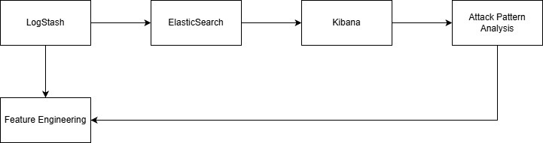
Fig 6.2.2 : Intelligence Processing Diagram
ALGORITHM AND TECHNIQUES
Algorithm Explanation
In this project, machine learning algorithms are used to detect and classify cyber attacks based on honeypot session data. The system uses both unsupervised and supervised learning approaches. Isolation Forest is used for anomaly detection, where it identifies unusual attacker behavior by analyzing features such as session duration, number of commands, login attempts, and file activities. It isolates abnormal sessions using random decision trees and assigns anomaly scores to detect potential threats .
Random Forest is used as a supervised learning algorithm for attack classification. It classifies sessions into categories such as BENIGN, RECON, and MALICIOUS based on extracted features. The model is trained using labeled data and evaluates performance using accuracy, confusion matrix, and prediction confidence. It uses multiple decision trees and majority voting to improve accuracy and reduce overfitting .
The system also includes a real-time orchestration module that collects session data from Elasticsearch, extracts features, applies scaling, and performs classification using the trained Random Forest model. Based on the prediction and confidence level, adaptive actions such as enabling logging, modifying banners, or deploying fake credentials are executed on the honeypot system .

Used Python Packages:
Scikit-learn:
- A machine learning library that provides various ML algorithms.
- Used modules include train_test_split, classifiers, and accuracy_score for model evaluation.

NumPy:
- A numerical library used for fast mathematical operations.
- Helps in handling arrays and data manipulation.

Pandas:
- Used for reading and writing data files.
- Enables easy data manipulation using Data Frames.

Matplotlib:
- Used for data visualization to identify patterns in the dataset.
- Helps in plotting graphs like charts and histograms.

6.2.3 Isolation Forest:
Isolation Forest is an unsupervised machine learning algorithm used for anomaly detection. It identifies unusual behavior by isolating data points using random decision trees. Sessions with shorter path lengths are considered anomalies. This model helps detect unknown and zero-day attacks without requiring labeled data, making it efficient for real-time threat detection.
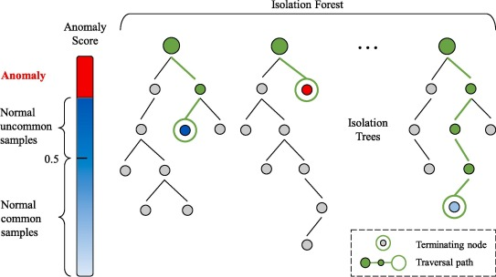
Fig 6.2.3 : Isolation Forest Diagram

6.2.4 Random Forest Classifier:
Random Forest is a supervised learning algorithm used for classifying attacks. It combines multiple decision trees to improve accuracy and reduce overfitting. The model classifies attacks into categories such as brute force, scanning, and malware activity. It provides high accuracy and reliable predictions by using majority voting across trees.
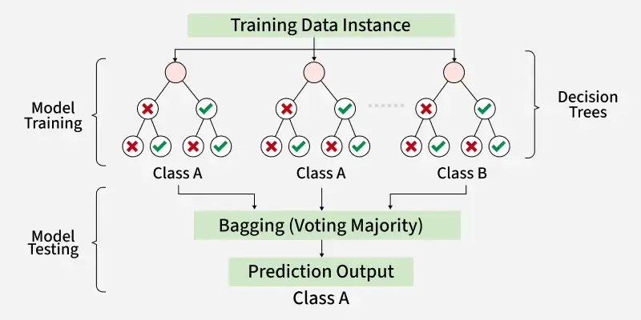
Fig 6.2.4 : Random Forest Diagram

6.2.5 Adaptation and Response Layer:
The Adaptation Layer dynamically modifies honeypot behavior based on detected threats. A Flask-based orchestrator triggers actions such as changing credentials, modifying banners, and updating system responses. This helps in increasing attacker engagement and collecting more detailed attack data. The system continuously improves its response using feedback from attacker interactions.

6.3 PROPOSED METHODOLOGY

The methodology describes the process of developing and evaluating the Deception-as-a-Service system. Data is collected using distributed honeypots like Cowrie and Dionaea, capturing attack sessions from multiple regions. A labeled dataset is created by analyzing attacker behavior and categorizing attacks such as brute force, reconnaissance, and malware activity. Preprocessing includes cleaning, removing duplicates, and normalizing data for analysis. Feature engineering extracts important attributes such as session duration, command patterns, authentication attempts, and network details. Machine learning models are trained using these features, where Isolation Forest detects anomalies and Random Forest classifies attack types. The models are evaluated using metrics like accuracy, precision, and recall to ensure reliable performance. The deployment phase uses containerized infrastructure with Docker and ELK stack for log processing and visualization. A Flask-based service performs real-time analysis and adaptive response, while monitoring tools ensure system performance and reliability.

6.3.1 Feature Engineering

Feature engineering converts raw honeypot logs into meaningful data for machine learning. Features include session duration, number of commands, login attempts, and network details. These features help in identifying attacker behavior patterns. Data is normalized and scaled to ensure accurate model performance.

6.3.2 Machine Learning Pipeline
The machine learning pipeline includes data loading, feature extraction, model training, and evaluation. Isolation Forest is used for anomaly detection on unlabeled data, while Random Forest is trained on labeled data for classification. The pipeline ensures accurate detection and efficient processing of attack data.

6.3.3 Training Process

The training process involves preparing the dataset, splitting it into training and testing sets, and training models using selected features. Hyperparameters are tuned to improve accuracy, and models are saved for real-time usage. The training process ensures reliable detection of cyber attacks.

6.3.4 Validation Process
The validation process evaluates model performance using metrics such as accuracy, precision, recall, and confusion matrix. Cross-validation ensures consistent performance across different datasets. Error analysis helps in improving model accuracy and reducing false detections.

6.4 DEPLOY

The system is deployed using cloud-based infrastructure with Docker containerization for scalability and reliability. Honeypots like Cowrie and Dionaea run as containers, while the ELK stack processes and visualizes logs. Machine learning models are deployed using a Flask-based API for real-time analysis and prediction.
The orchestration service dynamically modifies honeypot behavior based on detected threats, enabling adaptive responses. Monitoring tools track system performance, and deployment automation ensures smooth updates and maintenance. This approach provides a scalable and efficient cybersecurity solution.

CHAPTER 7

CODING & TESTING

7.1 VALUE CONVENTIONS
Value conventions ensure code consistency, readability, and maintainability. Naming conventions use snake_case for variables and functions, PascalCase for classes, and uppercase for constants. Type annotations are used for clarity and error checking. Code formatting follows PEP 8 standards with proper indentation, spacing, and structure. Documentation is maintained using docstrings and comments for better understanding. Configuration values are stored externally to improve security and flexibility.

7.2 SCRIPT WRITING AND COMMENTING STANDARD

Scripts follow a structured format with proper module organization, imports, functions, and classes. Functions are designed to perform specific tasks with clear names and minimal complexity. Error handling uses exceptions and logging for better debugging. Logging is implemented with different levels such as INFO, WARNING, and ERROR. Testing includes unit and integration tests to ensure reliability. Version control is maintained using Git with proper commit practices and code reviews. Security practices include input validation and safe data handling, while performance is optimized using efficient algorithms and resource management

7.3 MESSAGE BOX FORMAT

The system uses standardized formats for API responses, alerts, and logs. API responses follow a structured JSON format with status, data, and error fields. Alerts include details such as severity, attack type, confidence score, and source information. Dashboard notifications provide real-time updates for monitoring. Log messages are structured for easy analysis and debugging. Error messages are clear and informative, while progress indicators provide feedback during long operations.

CHAPTER 8
SYSTEM DESCRIPTION

8.1 DOCKER CONTAINERIZATION

Docker containerization is used to deploy honeypots and system components in isolated and portable environments. Containers run Cowrie and Dionaea honeypots with proper configurations and logging. Docker networking enables communication between components while maintaining isolation, and volumes ensure persistent storage of logs and data. Docker Compose is used to manage multiple containers efficiently.

8.2 ELASTICSEARCH
Elasticsearch is used for storing, indexing, and analyzing honeypot log data. It provides fast search capabilities using an inverted index and supports queries, filtering, and aggregation. The distributed architecture ensures scalability and reliability, while index management improves performance and storage efficiency.

8.3 PYTHON AND FLASK
Python is used for machine learning, data processing, and system development using libraries like Pandas, NumPy, and Scikit-learn. Flask is used to build REST APIs for real-time analysis and orchestration. It handles requests, processes data, and returns responses. The system supports parallel processing using servers like Gunicorn and ensures security through authentication, validation, and encryption.

CHAPTER 9
CODING

9.1 CODING

MODULE 1:

import pandas as pd
from sklearn.ensemble import IsolationForest
from sklearn.preprocessing import StandardScaler
import joblib
import matplotlib.pyplot as plt
df = pd.read_csv('sessions_features.csv')
feature_cols = [
'duration_seconds', 'num_commands', 'unique_commands',
'has_download', 'has_priv_esc', 'has_recon',
'login_failures', 'login_success', 'file_uploads'
]
X = df[feature_cols].fillna(0)
scaler = StandardScaler()
X_scaled = scaler.fit_transform(X)
model = IsolationForest(contamination=0.2, random_state=42, n_estimators=100)
model.fit(X_scaled)
df['anomaly_score'] = model.decision_function(X_scaled)
df['is_anomaly'] = model.predict(X_scaled)
joblib.dump(model, 'cowrie_anomaly_model.pkl')
joblib.dump(scaler, 'feature_scaler.pkl')
df.to_csv('session_predictions.csv', index=False)
fig, axes = plt.subplots(2, 2, figsize=(12, 10))
axes[0, 0].barh(range(len(df)), df.sort_values('anomaly_score')['anomaly_score'],
color=['red' if x == -1 else 'green' for x in df.sort_values('anomaly_score')['is_anomaly']])
axes[0, 0].set_xlabel('Anomaly Score')
axes[0, 0].set_title('Session Anomaly Scores')
axes[0, 1].scatter(df['duration_seconds'], df['num_commands'],
c=['red' if x == -1 else 'green' for x in df['is_anomaly']], s=100, alpha=0.6)
axes[0, 1].set_xlabel('Duration (s)')
axes[0, 1].set_ylabel('Commands')
axes[0, 1].set_title('Session Behavior')
axes[1, 0].barh(feature_cols, X.var())
axes[1, 0].set_xlabel('Variance')
axes[1, 0].set_title('Feature Variance')
axes[1, 1].bar(['Download', 'PrivEsc', 'Recon'], df[['has_download', 'has_priv_esc', 'has_recon']].sum())
axes[1, 1].set_title('Attack Patterns')
plt.tight_layout()
plt.savefig('anomaly_analysis.png', dpi=150, bbox_inches='tight')
print(f" Trained model: {(df['is_anomaly'] == -1).sum()}/{len(df)} anomalies detected")
print(" Saved: cowrie_anomaly_model.pkl, feature_scaler.pkl, session_predictions.csv, anomaly_analysis.png")

MODULE 2:
import pandas as pd
from sklearn.ensemble import RandomForestClassifier
from sklearn.model_selection import train_test_split
from sklearn.metrics import accuracy_score, classification_report, confusion_matrix
from sklearn.preprocessing import StandardScaler, LabelEncoder
import joblib
import matplotlib.pyplot as plt
import seaborn as sns
df = pd.read_csv('sessions_features.csv')
def classify_session(row):
if row['has_download'] == 1 and row['has_priv_esc'] == 1:
return 'MALICIOUS'
elif row['has_recon'] == 1 or row['login_failures'] >= 2:
return 'RECON'
else:
return 'BENIGN'

df['label'] = df.apply(classify_session, axis=1)
feature_cols = ['duration_seconds', 'num_commands', 'unique_commands',
'has_download', 'has_priv_esc', 'has_recon',
'login_failures', 'login_success', 'file_uploads']
X = df[feature_cols].fillna(0)
y = df['label']
label_encoder = LabelEncoder()
y_encoded = label_encoder.fit_transform(y)
scaler = StandardScaler()
X_scaled = scaler.fit_transform(X)
X_train, X_test, y_train, y_test = train_test_split(
X_scaled, y_encoded, test_size=0.3, random_state=42, stratify=y_encoded
)
rf_model = RandomForestClassifier(n_estimators=100, max_depth=10, random_state=42, n_jobs=-1)
rf_model.fit(X_train, y_train)
y_pred = rf_model.predict(X_test)
accuracy = accuracy_score(y_test, y_pred)
df['predicted_label'] = label_encoder.inverse_transform(rf_model.predict(X_scaled))
df['prediction_confidence'] = rf_model.predict_proba(X_scaled).max(axis=1)
joblib.dump(rf_model, 'random_forest_model.pkl')
joblib.dump(scaler, 'rf_scaler.pkl')
joblib.dump(label_encoder, 'rf_label_encoder.pkl')
df.to_csv('rf_predictions.csv', index=False)
feature_importance = pd.DataFrame({
'feature': feature_cols,
'importance': rf_model.feature_importances_
}).sort_values('importance', ascending=False)
fig, axes = plt.subplots(2, 2, figsize=(14, 10))
axes[0, 0].barh(feature_importance['feature'], feature_importance['importance'])
axes[0, 0].set_xlabel('Importance')
axes[0, 0].set_title('Feature Importance')
axes[0, 0].invert_yaxis()
cm = confusion_matrix(y_test, y_pred)
sns.heatmap(cm, annot=True, fmt='d', cmap='Blues',
xticklabels=label_encoder.classes_, yticklabels=label_encoder.classes_, ax=axes[0, 1])
axes[0, 1].set_title('Confusion Matrix')
class_counts = df['label'].value_counts()
axes[1, 0].bar(class_counts.index, class_counts.values, color=['green', 'orange', 'red'])
axes[1, 0].set_title('Class Distribution')
axes[1, 0].tick_params(axis='x', rotation=45)
axes[1, 1].hist(df['prediction_confidence'], bins=10, edgecolor='black')
axes[1, 1].set_title('Prediction Confidence')
axes[1, 1].axvline(x=0.8, color='r', linestyle='--', label='80% threshold')
axes[1, 1].legend()
plt.tight_layout()
plt.savefig('rf_analysis.png', dpi=150, bbox_inches='tight')
print(f" Random Forest trained: {accuracy*100:.1f}% accuracy")
print(f" Class distribution: {dict(df['label'].value_counts())}")
print(f" Saved: random_forest_model.pkl, rf_scaler.pkl, rf_label_encoder.pkl, rf_predictions.csv, rf_analysis.png")

9.2 SCREEN SHOTS:

9.2.1 API HEALTH CHECK:

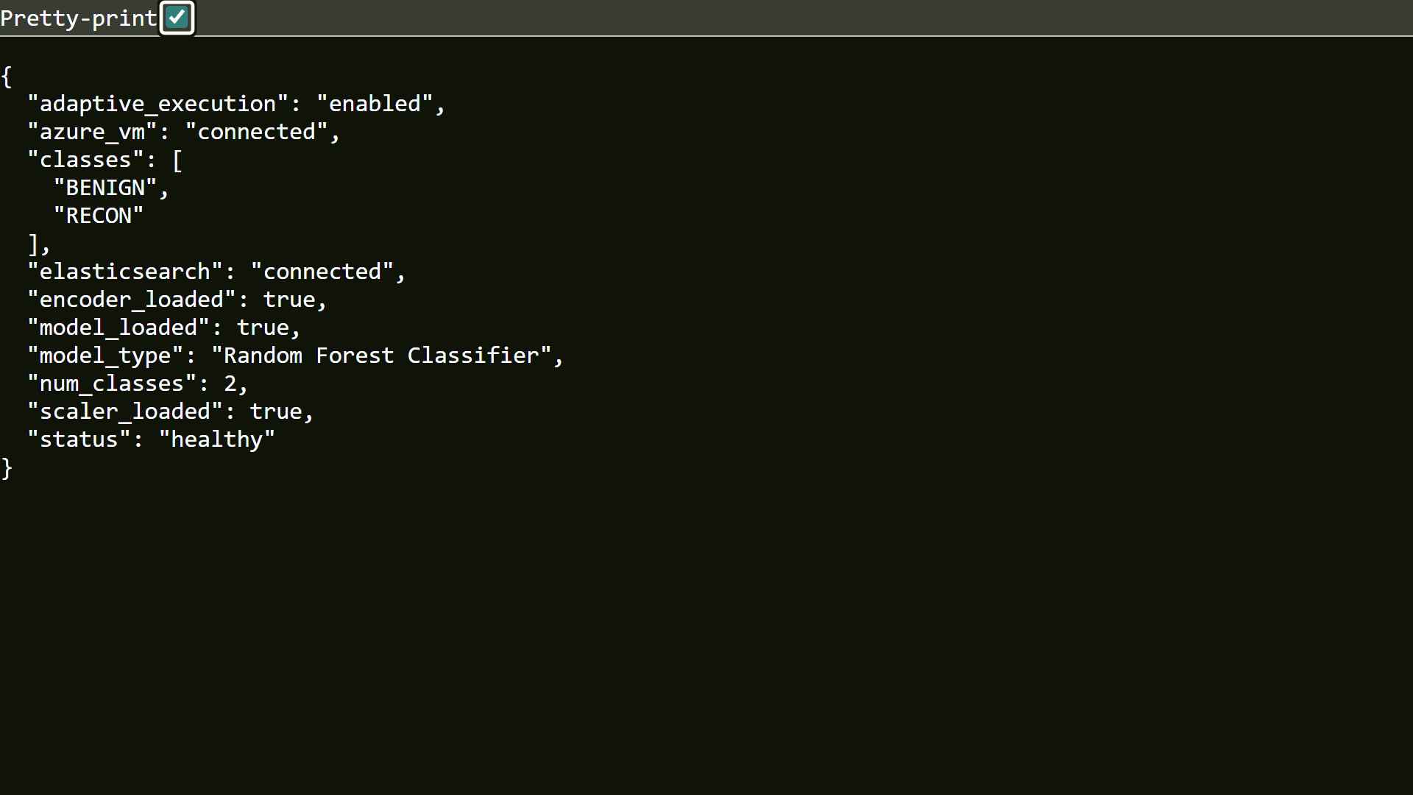

Fig 9.2.1 : API Health Check

9.2.2 KIBANA DASHBOARD:

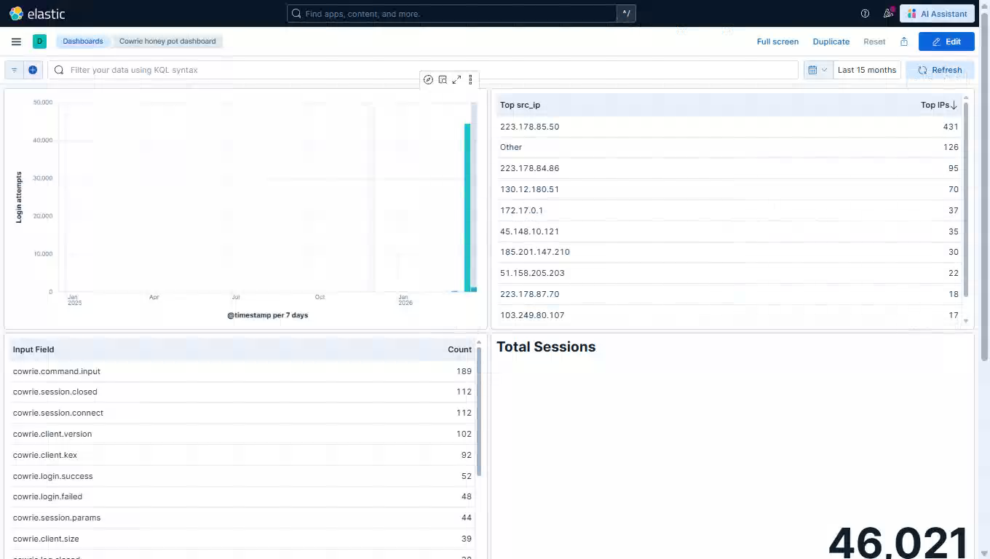

Fig 9.2.2 : Kibana Dashboard

9.2.3 ADAPTIVE RESPONSE API OUTPUT:
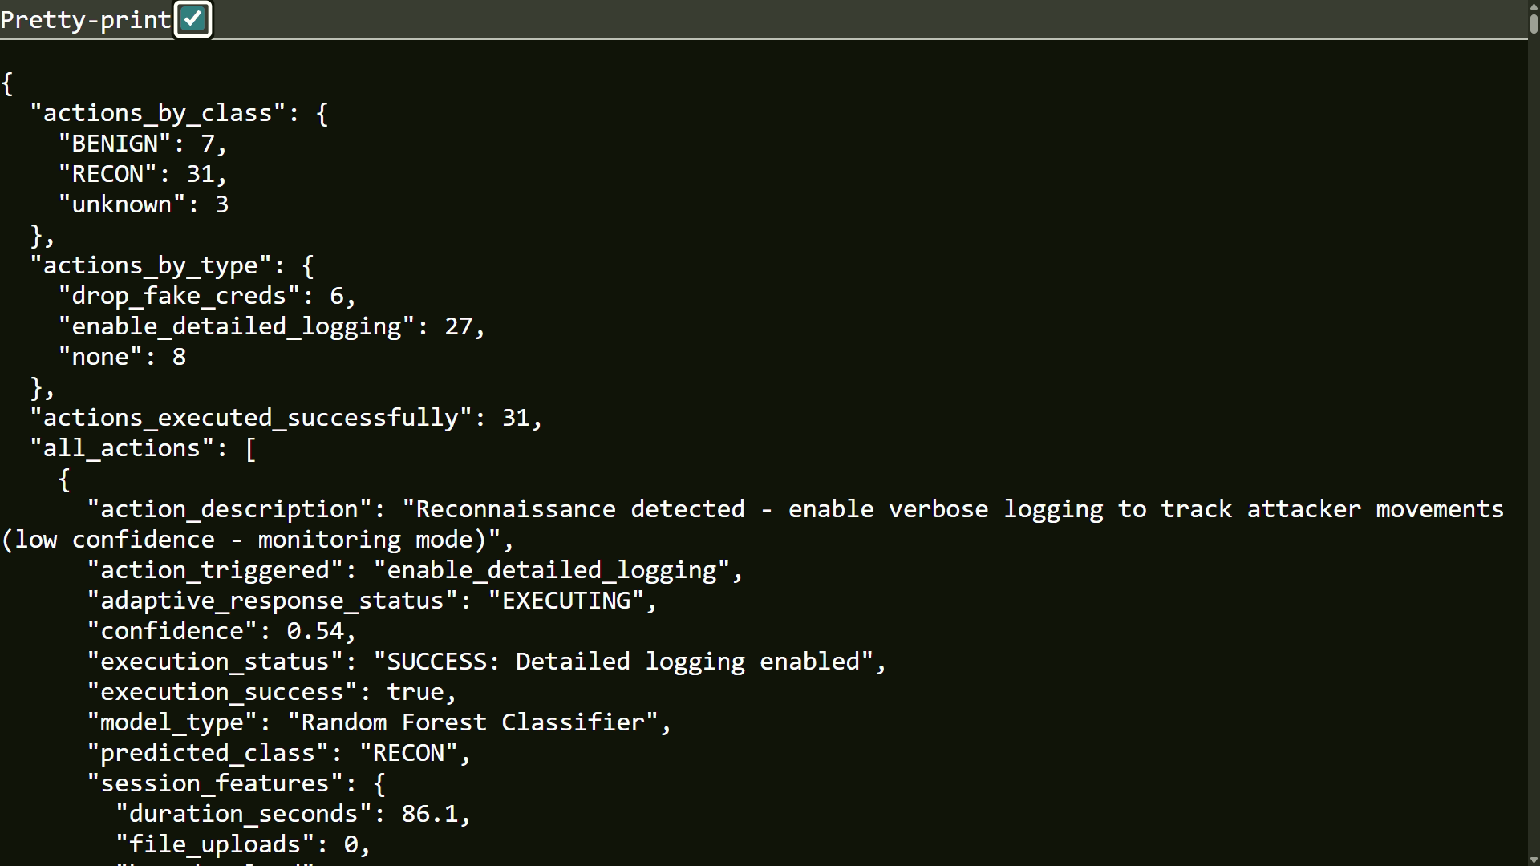

Fig 9.2.3 : Adaptive Response API Output

9.2.4 ATTACKER SESSION INSIDE HONEYPOT:

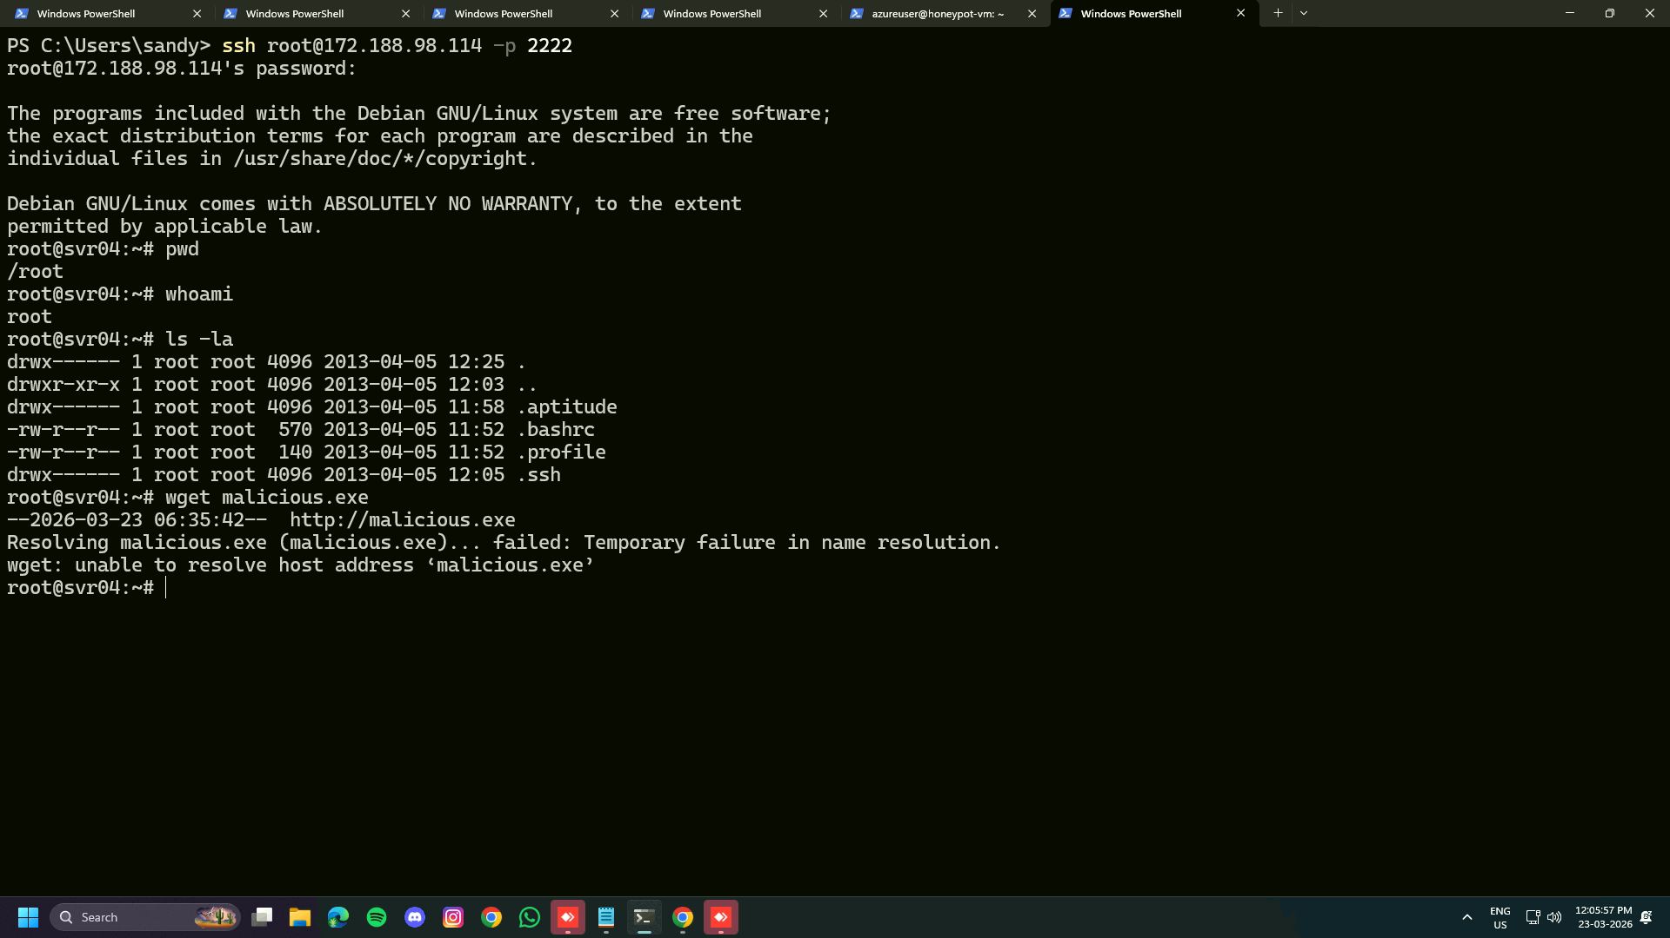

Fig 9.2.4 : Attacker Session Inside Honeypot

CHAPTER 10

RESULT & DISCUSSION

10.1 RESULT:
The experimental results demonstrate that the proposed Deception-as-a-Service system effectively improves threat detection and analysis. The anomaly score graph shows clear separation between normal and anomalous sessions, indicating that the model successfully identifies suspicious activities. Session behavior analysis highlights that attacks with higher duration and command count are more likely to be malicious, supporting effective anomaly detection.
The feature variance and importance graphs indicate that features such as session duration and number of commands have the highest impact on detection. The Random Forest model also shows strong classification performance, as seen in the confusion matrix where all test instances are correctly classified with minimal errors. The class distribution and prediction confidence graphs further confirm that the model provides reliable predictions with high confidence levels.
Overall, the system achieves high accuracy and effectively distinguishes between benign and attack sessions. The results confirm that combining machine learning with honeypot data improves detection capability, enhances analysis of attacker behavior, and provides better insights for cybersecurity defense.
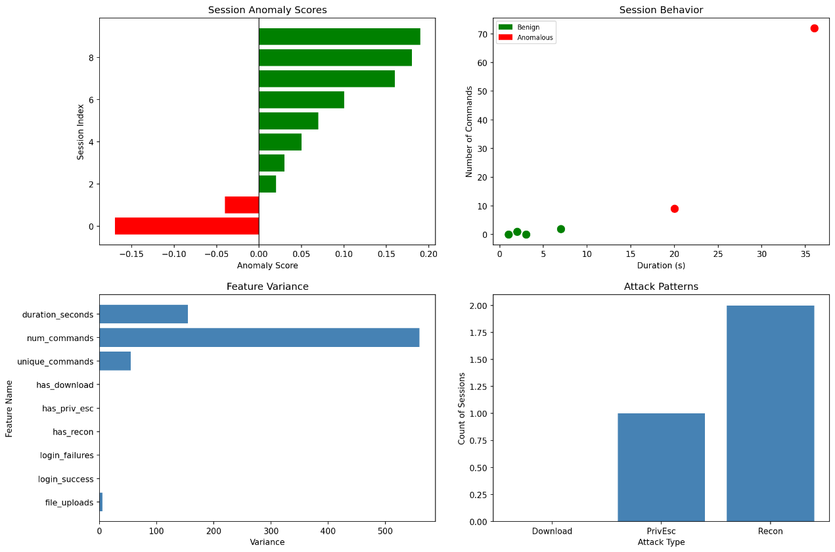
Fig 10.1 : Isolation Forest Graph

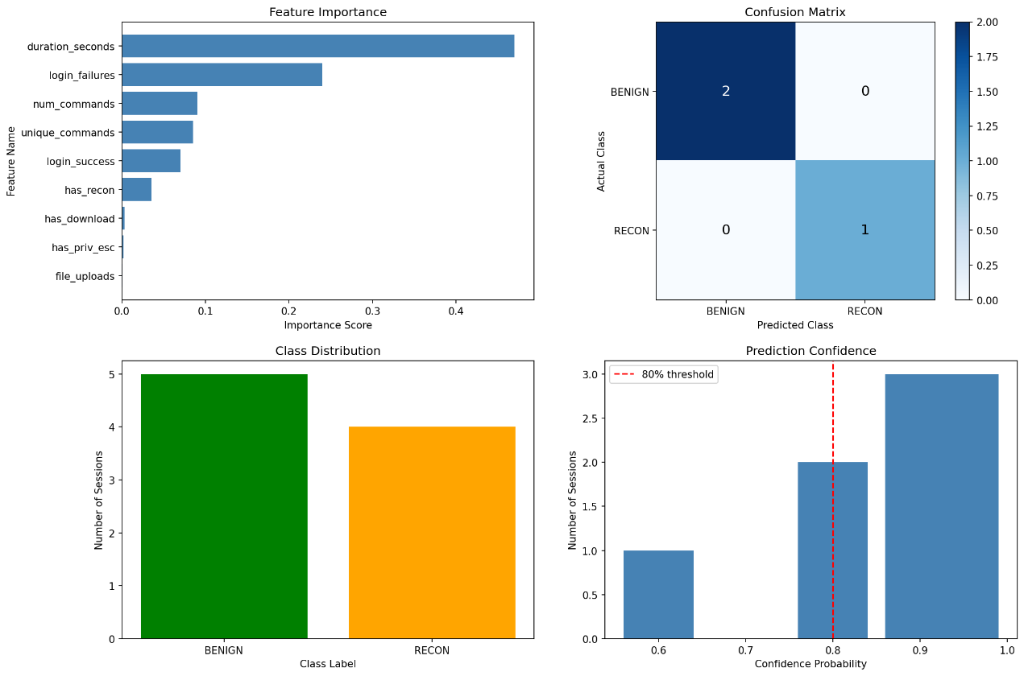

Fig.10.2 : Random Forest Graph

10.2 CONCLUSION:

This work presents an Adaptive AI-Powered Honeypot that overcomes limitations of static systems using machine learning and dynamic adaptation. The system achieves high detection accuracy and improves attacker engagement while reducing detection risk.
Experimental results show effective analysis of global attack patterns, with models like Random Forest providing accurate classification. Adaptive techniques such as banner changes and honeytokens enhance interaction and intelligence collection.
The system enables real-time monitoring through dashboards and supports proactive security responses. Overall, adaptive honeypots provide a strong and practical solution for modern cybersecurity, with future improvements focusing on reinforcement learning and multi-protocol support.

10.3 FUTURE WORK:

The proposed Adaptive AI-Powered Honeypot system shows strong performance, but further improvements are possible. Future work can include integrating reinforcement learning to automatically optimize adaptation strategies and improve attacker engagement. Additionally, expanding the system to support multi-protocol and IoT environments such as industrial and smart devices will enhance threat detection across wider domains.

REFERENCES:

- S. Yeldi et al., "Enhancing network intrusion detection system with honeypot," TENCON 2003. Conference on Convergent Technologies for Asia-Pacific Region, Bangalore, India, 2003, pp. 1521-1526 Vol.4, doi: 10.1109/TENCON.2003.1273174.

- R. Budiarto, A. Samsudin, C. W. Heong and S. Noori, "Honeypots: why we need a dynamics honeypots?," Proceedings. 2004 International Conference on Information and Communication Technologies: From Theory to Applications, 2004., Damascus, Syria, 2004, pp. 565-566, doi: 10.1109/ICTTA.2004.1307887.

- Kuwatly, M. Sraj, Z. Al Masri and H. Artail, "A dynamic honeypot design for intrusion detection," The IEEE/ACS International Conference onPervasive Services, 2004. ICPS 2004. Proceedings., Beirut, Lebanon, 2004, pp. 95-104, doi: 10.1109/PERSER.2004.1356776.

- S. Almotairi, A. Clark, G. Mohay and J. Zimmermann, "A Technique for Detecting New Attacks in Low-Interaction Honeypot Traffic," 2009 Fourth International Conference on Internet Monitoring and Protection, Venice/Mestre, Italy, 2009, pp. 7-13, doi: 10.1109/ICIMP.2009.9.

- Jian Bao, Chang-peng Ji and Mo Gao, "Research on network security of defense based on Honeypot," 2010 International Conference on Computer Application and System Modeling (ICCASM 2010), Taiyuan, China, 2010, pp. V10-299-V10-302, doi: 10.1109/ICCASM.2010.5622780.
- S. Chamotra, J. S. Bhatia, R. Kamal and A. K. Ramani, "Deployment of a low interaction honeypot in an organizational private network," 2011 International Conference on Emerging Trends in Networks and Computer Communications (ETNCC), Udaipur, India, 2011, pp. 130-135, doi: 10.1109/ETNCC.2011.5958501.

- G. Wagener, R. State, T. Engel and A. Dulaunoy, "Adaptive and self-configurable honeypots," 12th IFIP/IEEE International Symposium on Integrated Network Management (IM 2011) and Workshops, Dublin, Ireland, 2011, pp. 345-352, doi: 10.1109/INM.2011.5990710.

- Koniaris, G. Papadimitriou and P. Nicopolitidis, "Analysis and visualization of SSH attacks using honeypots,"Eurocon2013, Zagreb, Croatia, 2013, pp.65-72, doi:10.109/EUROCON.2013.6624967.

- D. Fraunholz, M. Zimmermann and H. D. Schotten, "An adaptive honeypot configuration, deployment and maintenance strategy," 2017 19th International Conference on Advanced Communication Technology (ICACT), PyeongChang, Korea (South), 2017, pp. 53-57, doi: 10.23919/ICACT.2017.7890056.

- V. A. Perevozchikov, T. A. Shaymardanov and I. V. Chugunkov, "New techniques of malware detection using FTP Honeypot systems," 2017 IEEE Conference of Russian Young Researchers in Electrical and Electronic Engineering (EIConRus), St. Petersburg and Moscow, Russia, 2017, pp. 204-207, doi: 10.1109/EIConRus.2017.7910529.

- Y. Zhang, C. Di, Z. Han, Y. Li and S. Li, "An Adaptive Honeypot Deployment Algorithm Based on Learning Automata," 2017 IEEE Second International Conference on Data Science in Cyberspace (DSC), Shenzhen, China, 2017, pp. 521-527, doi: 10.1109/DSC.2017.52.

- P. D. Ali and T. G. Kumar, "Malware capturing and detection in dionaea honeypot," 2017 Innovations in Power and Advanced Computing Technologies (i-PACT), Vellore, India, 2017, pp. 1-5, doi: 10.1109/IPACT.2017.8245158.

- D. Kumar and A. Girdhar, "Network monitoring & analysis along with comparative study of honeypots," 2017 International Conference on Intelligent Sustainable Systems (ICISS), Palladam, India, 2017, pp. 736-739, doi: 10.1109/ISS1.2017.8389270.

- H. Almohannadi, I. Awan, J. Al Hamar, A. Cullen, J. P. Disso and L. Armitage, "Cyber Threat Intelligence from Honeypot Data Using Elasticsearch," 2018 IEEE 32nd International Conference on Advanced Information Networking and Applications (AINA), Krakow, Poland, 2018, pp. 900-906, doi: 10.1109/AINA.2018.00132.

- K. R. Sekar, V. Gayathri, G. Anisha, K. S. Ravichandran and R. Manikandan, "Dynamic Honeypot Configuration for Intrusion Detection," 2018 2nd International Conference on Trends in Electronics and Informatics (ICOEI), Tirunelveli, India, 2018, pp. 1397-1401, doi: 10.1109/ICOEI.2018.8553956.

- V. Sethia and A. Jeyasekar, "Malware Capturing and Analysis using Dionaea Honeypot," 2019 International Carnahan Conference on Security Technology (ICCST), Chennai, India, 2019, pp. 1-4, doi: 10.1109/CCST.2019.8888409.
- K. Saikawa and V. Klyuev, "Detection and Classification of Malicious Access using a Dionaea Honeypot," 2019 10th IEEE International Conference on Intelligent Data Acquisition and Advanced Computing Systems: Technology and Applications (IDAACS), Metz, France, 2019, pp. 844-848, doi: 10.1109/IDAACS.2019.8924340.

- M. M. Matin and B. Rahardjo, "Malware Detection Using Honeypot and Machine Learning," 2019 7th International Conference on Cyber and IT Service Management (CITSM), Jakarta, Indonesia, 2019, pp. 1-4, doi: 10.1109/CITSM47753.2019.8965419.

IEEE PAPER

